1. Use select,where,order by, group by

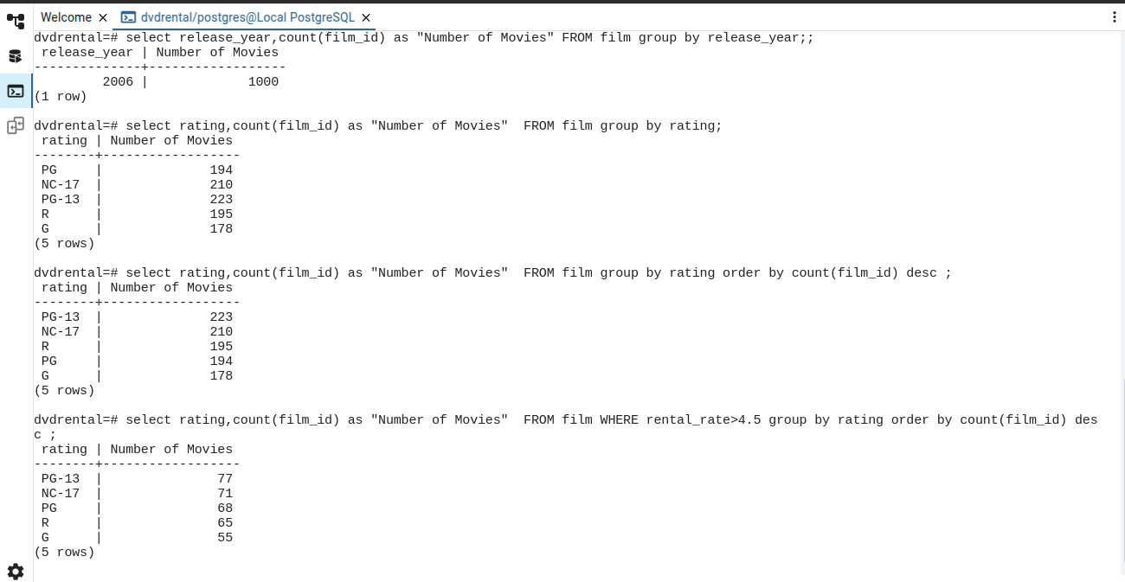

1. Use Joins

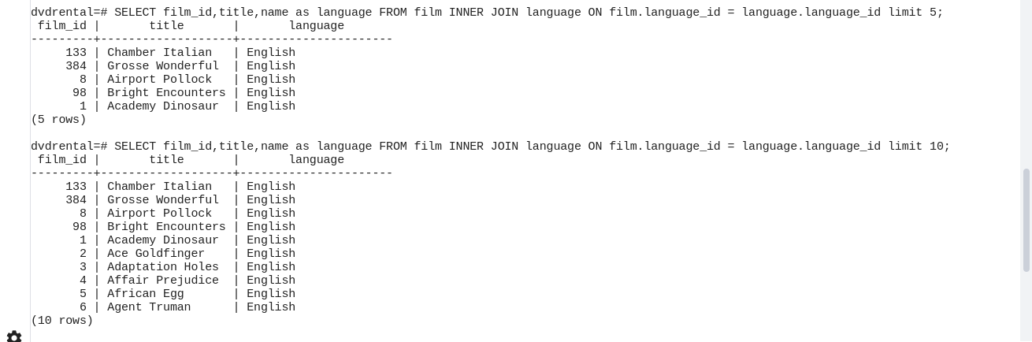

1. Subqueries

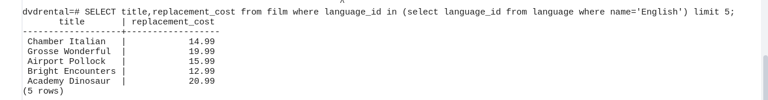

1. Aggregate Functions





1. Create views

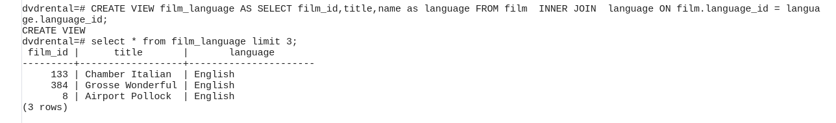

1. Indexes

